A

PROJECT REPORT

ON

“**SCHOOL-LINK**“

FOR

**“Adhira International School”**

SUBMITTED BY

**VISHAL ASHOK PAWAR**

**(4390)**

D. Y. PATIL INSTITUTE OF MCA AND MANAGEMENT AKURDI, PUNE -411044

ACADEMIC YEAR 2023-2024

# Acknowledgement

I would take the opportunity to thank **Dr. K. Nirmala, Director, DYPIMCA and Management** for her support, extended to me throughout the course.

I would like to thank **Dr. Kavita Suryawanshi, Vice Principal,** for her scholarly disposition, timely guidance, support and cooperation.

I would like to thank **Ms. Vanita Patil** for her kind guidance, keen interest, continuous encouragement and inspiration throughout the project work.

Finally, I gratefully thank all the faculty members of DYPIMCA and Management for their cooperation and support.

I also thankful to get constant encouragement, support and guidance from all Teaching and Non- Teaching Staff for their timely support which helped us in successfully completion of our project work.

Student Name:-Vishal Ashok Pawar

MCA II

DIV :- A **(4390)**

**Dr. D. Y. Patil Pratishthan’s**

**D. Y. Patil Institute of Master of Computer Applications and Management**

**(M.C.A. Programme)**

(Approved by AICTE, New Delhi & Affiliated to Savitribai Phule Pune University)

**Dr. D. Y. Patil Educational Complex, Sector 29, Pradhikaran, Akurdi, Pune – 411 044**Tel No: (020)27640998, Website: www.dypimca.ac.in, E-mail : [director@dypimca.ac](mailto:director@dypimca.ac).in

**INDEX**

|  |  |  |
| --- | --- | --- |
| **Chapter No** |  | **Details** |
| **1** |  | **Introduction** |
|  | 1.1 | Company Profile / Institute Profile / Client Profile |
|  | 1.2 | Abstract |
|  | 1.3 | Existing System and Need for System |
|  | 1.4 | Scope of System |
|  | 1.5 | Operating Environment - Hardware and Software |
|  | 1.6 | Brief Description of Technology Used   * + 1. Operating systems used (Windows or Unix)     2. RDBMS/No Sql used to build database (mysql/ oracle, Teradata, etc.) |
| **2** |  | **Proposed System** |
|  | 2.1 | Study of Similar Systems ( If required research paper can be included) |
|  | 2.2 | Feasibility Study |
|  | 2.3 | Objectives of Proposed System |
|  | 2.4 | Users of System |
| **3** |  | **Analysis and Design** |
|  | 3.1 | System Requirements (Functional and Non-Functional requirements) |
|  | 3.2 | Entity Relationship Diagram (ERD) |
|  | 3.3 | Table Structure |
|  | 3.4 | Use Case Diagrams |
|  | 3.5 | Class Diagram |
|  | 3.6 | Activity Diagram |
|  | 3.7 | Deployment Diagram |
|  | 3.8 | Module Hierarchy Diagram |
|  | 3.9 | Sample Input and Output Screens (Screens must have valid data. All  reports must have at-least 5 valid records.) |
| **4** |  | **Coding** |
|  | 4.1 | Algorithms |
|  | 4.2 | Code snippets |
| **5** |  | **Testing** |
|  | 5.1 | Test Strategy |
|  | 5.2 | Unit Test Plan |
|  | 5.3 | Acceptance Test Plan |
|  | 5.4 | Test Case / Test Script |
|  | 5.5 | Defect report / Test Log |
| **6** |  | **Limitations of Proposed System** |
| **7** |  | **Proposed Enhancements** |
| **8** |  | **Conclusion** |
| **9** |  | **Bibliography** |
| **10** |  | **Publication / Competition certificates** |
| **11** |  | **Appendix – Cost sheet , Data sheet** |
| **12** |  | **User Manual** (All screens with proper description/purpose Details  about validations related to data to be entered.) |

**Chapter No. 1**

**INTRODUCTION**

## 1 COMPANY PROFILE

**Client Name**: Adhira International School

**Project Name:** School-Link: School Bus Tracking Application

**Client Overview:**

Adhira International School is a distinguished institution dedicated to nurturing young minds through a blend of academic excellence and holistic development. The school combines a rigorous CBSE curriculum with a wide range of co-curricular activities to ensure the comprehensive growth of its students. With a strong emphasis on moral and cultural values, Adhira International School aims to create well-rounded, responsible global citizens.

**Project Overview:**

To enhance the safety and convenience of the school transportation system by providing real-time tracking of school buses for students, parents, and school administrators.

Features:

1. Real-Time Tracking: Allows parents and school staff to track the location of school buses in real-time.

2. Notifications: Sends alerts to parents when the bus is approaching the pickup/drop-off point.

3. Safety Alerts: Notifies school administrators of any delays or issues during the bus route.

4. Route Optimization: Provides the most efficient routes for bus drivers to ensure timely pickups and drop-offs.

6. Parent Portal: A user-friendly interface for parents to check bus schedules, track buses, and receive notifications.

**Benefits:**

- Enhanced Safety: Ensures the safety of students during their commute to and from school.

- Peace of Mind for Parents:Provides parents with real-time information and updates on their child’s bus status.

- Efficient Operations: Helps the school manage and optimize bus routes, improving overall efficiency.

- Communication: Facilitates better communication between parents, school staff, and bus drivers.

## 1.1 INTRODUCTION :

The School-Link mobile application addresses the critical need for enhanced child safety during transit, providing a comprehensive and innovative solution for parents, school administrators, and drivers. In response to growing concerns over children's safety during their commute, and the increasing demand for technological solutions that offer peace of mind, School-Link leverages cutting-edge technologies to transform the management of nursery school transportation.

Parents often experience anxiety about their children's safety while they are in transit to and from school. The School-Link app directly addresses these concerns by offering real-time tracking of school buses, enabling parents to monitor their child's location at any given moment. This transparency provides reassurance and helps alleviate worries about potential delays or safety incidents.

For school administrators, managing the logistics of student transportation can be a complex task. School-Link simplifies this process by providing a centralized platform to oversee bus routes, schedules, and student ridership. This centralized management capability allows schools to optimize routes,ensuring efficient use of resources and minimizing delays .Additionally, administrators can access detailed reports and analytics to improve overall

transit operations.

Drivers play a crucial role in ensuring the safety and efficiency of student transportation. The School-Link app equips drivers with real-time location tracking and robust communication tools. These features enable drivers to stay connected with school administrators and parents, providing timely updates and addressing any issues that may arise during the journey. The app also facilitates two-way communication, allowing drivers to report incidents or delays and receive immediate instructions.

School-Link creates a win-win-win situation for all involved parties. Schools gain enhanced control over transportation logistics, drivers benefit from improved tools and support, and parents receive real-time updates on their child's whereabouts. This comprehensive approach not only enhances safety but also fosters a sense of community and trust among parents, schools, and drivers.

By integrating advanced tracking, communication, and management features, the School-Link mobile application revolutionizes the way nursery school commuting is handled, setting a new standard for safety and efficiency in student transptation.

* 1. **ABSTRACT**

In an era marked by heightened concerns over child safety and the increasing reliance on technology, the School-Link mobile application emerges as a comprehensive solution designed to ensure the secure and efficient transit of nursery school children. This innovative application addresses the critical need for real-time tracking, effective communication, and centralized management in school transportation systems, providing a multifaceted approach to enhance safety and operational efficiency. Leveraging advanced GPS technology, School-Link offers parents live updates on their child’s location and transit status, significantly reducing anxiety and providing peace of mind. School administrators benefit from a centralized management platform that enables efficient oversight and optimization of bus routes, schedules, and student ridership, streamlining operations and ensuring optimal resource utilization.

The app also facilitates seamless two-way communication between drivers and parents, as well as between drivers and school administrators, ensuring prompt resolution of any issues or delays and fostering transparency and trust. Designed with an intuitive interface, School-Link

is accessible and easy to use for all stakeholders, including parents, school administrators,

and drivers. Recognizing the critical importance of safeguarding sensitive data, the application implements robust security measures to protect against potential threats and vulnerabilities, ensuring the confidentiality and integrity of student information. Additionally, School-Link emphasizes meticulous cost estimation to ensure efficient resource allocation and mitigate project risks. Through thorough probabilistic assessments, stakeholders gain valuable insights into the anticipated costs and efforts required, enabling informed decision-making and optimizing project outcomes.

Overall, the School-Link mobile application represents a significant advancement in the domain of school transportation safety and management. By integrating real-time tracking, centralized management, and enhanced communication tools, it sets a new standard for ensuring the secure and efficient transit of nursery school children. With a steadfast commitment to information security and accurate cost estimation, School-Link stands poised

to revolutionize school transportation, offering a reliable and technologically advanced solution that benefits parents, school administrators, and drivers alike.

* 1. **EXISTING SYSTEM AND NEED FOR SYSTEM**

# Needs of System :

In the realm of school transportation, there exists a pressing need for streamlined processes and efficient management systems to address several critical challenges. Firstly, manual processes are pervasive in many school transportation operations, leading to errors, inefficiencies, and difficulties in data retrieval and analysis. This reliance on manual methods significantly hampers productivity and accuracy in managing bus routes, schedules, and student records. Secondly, the lack of real-time information poses a significant hurdle, as without automated systems, obtaining up-to-date data on bus locations, schedules, and student ridership becomes arduous.

Timely access to this information is essential for informed decision-making and proactive action in response to transportation dynamics. Additionally, limited communication capabilities hinder the ability to generate timely updates and notifications to parents, impeding effective communication and increasing anxiety about student well-being. These challenges underscore the need for a comprehensive and integrated management solution to ensure the safety and efficiency of school transportation

# Existing Systems:

The prevailing systems in many school transportation operations are characterized by manual processes and a lack of automation, leading to several operational inefficiencies. Manual management practices often result in inaccuracies and time-consuming tasks, such as tracking bus schedules, routes, and student attendance. Furthermore, the absence of integration with other systems or software exacerbates these challenges, fostering data silos, duplicated efforts, and inconsistencies in data management.

Communication processes, too, are typically manual, relying on phone calls or paper-based records, which can impede timely updates and effective communication with parents and school administrators. Overall, the existing systems fail to provide the necessary tools and capabilities to address the complexities of modern school transportation operations, highlighting the urgent need for a comprehensive and integrated management solution like the School-Link mobile application.

## SCOPE OF SYSTEM

The proposed School-Link mobile application aims to provide a comprehensive platform that seamlessly manages the entire school transportation experience for users, addressing key challenges faced by traditional school bus management systems and manual processes. With a focus on safety, efficiency, and accessibility, the system's scope encompasses various facets of school transportation, including real-time tracking, communication, route management, and student safety monitoring.

First and foremost, the system enables parents, school administrators, and drivers to manage school transportation activities easily, offering intuitive navigation and streamlined processes for tracking bus locations, managing routes, and communicating effectively. A

robust registration and profile management system ensures secure access for all users, safeguarding their personal information and preferences.

Furthermore, the system emphasizes quick and effortless access to real-time information on bus locations and schedules, allowing users to stay informed with minimal effort. Its user-friendly interface and intuitive design make it easy to navigate, ensuring a seamless experience for users of all backgrounds and technological proficiency levels.

One of the key features of the system is its ability to provide instant access to real-time bus tracking and updates, allowing parents to monitor their child's commute and school administrators to oversee transportation operations without the need for manual intervention. Moreover, the system ensures accuracy in route planning and schedule management,

enhancing user trust and confidence in the platform.

Additionally, the system offers robust communication tools, enabling two-way communication between drivers and parents, as well as between drivers and school administrators. This feature ensures timely updates and notifications, fostering transparency

and reducing anxiety about student well-being. With real-time alerts and notifications, users

can stay informed about any changes or delays, enhancing overall efficiency and safety.

Overall, the scope of the system encompasses a holistic approach to school transportation management, offering convenience, security, and efficiency to users while addressing their diverse needs and preferences in ensuring the safety and smooth operation of school bus services.

## OPERATING ENVIRONMENT – HARDWARE AND SOFTWARE

* + - **HARDWARE REQUIREMENTS :**
      * Processor: Intel i3 10th Generation & above.
      * Hard Disk: 25 GB Minimum.
      * RAM: 1 GB Minimum.

## SOFTWARE REQUIREMENTS :

* + - * Operating System: Android 5.0 (Lollipop) and above.
      * Front – End: XML (Extensible Markup Language)
      * Back - End: Java
      * Database: FireBase
      * Editor: Android Studio

## BRIEF DESCRIPTION OF TECHNOLOGY USED

1. **XML (Extensible Markup Language):**

XML, or Extensible Markup Language, is a markup language similar to HTML but designed to store and transport data, rather than display it. It uses tags to define data structures and hierarchies, making it easy to organize and exchange information between different systems and platforms. XML is commonly used for configuration files, data storage, and data exchange between web services.

2. **Java**:

Java is a widely-used programming language known for its versatility, portability, and robustness. It is commonly used for developing mobile apps, web applications, enterprise software, and more. Java applications run on the Java Virtual Machine (JVM), making them platform-independent. Java is favored for its rich ecosystem of libraries, frameworks, and tools, making it well-suited for a wide range of development tasks.

3. **Firebase:**

Firebase is a comprehensive platform provided by Google for developing mobile and web applications. It offers a wide range of services, including real-time database, authentication, cloud storage, hosting, and more. Firebase's real-time database is particularly popular for its ability to synchronize data in real-time across multiple clients, making it ideal for building collaborative and responsive applications. Firebase also provides authentication services, allowing users to sign in with email/password, social media accounts, or custom authentication systems. Additionally, Firebase offers cloud functions, which allow you to run server-side code in response to events triggered by Firebase services or HTTPS requests.

**Chapter No. 2**

**PROPOSED SYSTEM**

## PROPOSED SYSTEM

The proposed School-Link mobile application is centered on enhancing the safety and efficiency of school transportation systems. It focuses on providing a user-friendly interface with robust security measures to ensure the safety and well-being of students during their commute. By granting access only to authorized users, the system ensures controlled and secure transportation operations.

Efficient management of school bus routes and schedules is a primary objective of the proposed system. This includes real-time tracking of bus locations, monitoring of arrival and departure times, and ensuring adherence to designated routes. Safety features such as emergency alerts and student attendance tracking are seamlessly integrated into the system to enhance overall safety measures.

Real-time communication between drivers, parents, and school administrators is another crucial aspect addressed by the system. Features for sending notifications, receiving updates, and resolving issues promptly contribute to transparent and effective communication channels. Additionally, the system provides a platform for parents to track their child's whereabouts during the commute, offering peace of mind and reassurance.

Administrative tasks, such as managing student records and generating reports, are streamlined within the system to save time and improve productivity for school administrators. By providing insights into transportation performance metrics and student attendance patterns, the system facilitates informed decision-making and strategic planning.

Overall, the proposed School-Link mobile application is designed to be a comprehensive solution that addresses the specific needs and challenges faced in managing school transportation effectively and efficiently. Through its intuitive interface, robust security measures, and real-time communication capabilities, the system aims to optimize safety, streamline operations, and enhance the overall experience for students, parents, and school staff alike.

## PROBLEM STATEMENT

The problem statement addressed in the School-Link project focuses on the inefficiencies and challenges present in traditional school transportation management systems. Manual processes and lack of automation lead to errors, delays, and safety concerns during the commute of nursery school children.

The reliance on manual methods for managing bus routes, schedules, and student records results in inefficiencies and difficulties in data retrieval and analysis. Without an automated system, obtaining real-time information about bus locations, schedules, and student ridership becomes challenging, hindering decision-making and timely actions in response to transportation dynamics.

Moreover, manual communication processes between drivers, parents, and school administrators are error-prone and inefficient, leading to miscommunication and delays in resolving transportation-related issues. The lack of real-time updates and notifications further exacerbates safety concerns and parental anxiety about their child's well-being during the commute.

Additionally, the existing system's lack of integration with other school management systems or software leads to data silos and duplication of efforts. Administrative tasks such as managing student records and generating reports are time-consuming and prone to errors, further impacting operational efficiency.

Therefore, the School-Link project aims to address these limitations by developing a mobile application that automates and streamlines school transportation management processes. The proposed system will provide real-time tracking of bus locations, communication tools for drivers and parents, and administrative features for managing routes, schedules, and student records. By enhancing safety, efficiency, and communication in school transportation, the project aims to improve the overall experience for students, parents, and school staff.

## FEASIBILITY STUDY

The feasibility study for the project "School-Link" involves assessing the technical, economic, and operational aspects to determine the viability and potential success of the proposed system.

The feasibility study for " School-Link " project involves assessing technical requirements, economic viability, and operational practicality. This includes evaluating if the proposed system can be developed using available technology, determining the cost-effectiveness of implementation, and assessing how well the system will meet operational needs.

By analyzing these aspects, the feasibility study helps in determining the potential success and viability of the project within the dairy farm or processing facility.

* + 1. Technical Feasibility:
    2. Economic Feasibility:
    3. Operational Feasibility:

By conducting a comprehensive feasibility study encompassing technical, economic, and operational aspects, the project team can evaluate the viability of implementing the proposed system and make informed decisions regarding its development and deployment within the dairy farm or processing facility.

## TECHNICAL FEASIBILITY

**1. Technical Feasibility:-**

**"Technical feasibility is carried out to determine whether the company has the capability in terms of software, hardware, personnel, and expertise to handle the completion of the project."**

The technical feasibility study for the School-Link project involves evaluating whether the proposed mobile application can be developed using the available technology and resources. This assessment includes determining if the hardware and software requirements, such as mobile device compatibility, operating systems, and programming languages, are feasible within the existing infrastructure of the school transportation system.

By analyzing technical aspects, such as compatibility, scalability, and implementation complexity, the technical feasibility study aims to ensure that the mobile application can be effectively developed and integrated into the school transportation system's operations.

## ECONOMIC FEASIBILITY

**Economic Feasibility:**

**"Economic feasibility" entails evaluating whether a project can generate sufficient returns to justify its costs, considering factors like market demand, financial viability, and risk assessment. It determines if the endeavor is economically viable and likely to yield positive outcomes.**

The economic feasibility study for the School-Link project focuses on assessing the cost-effectiveness of implementing the mobile application. This evaluation includes estimating the initial development costs, ongoing maintenance expenses, and potential return on investment.

By analyzing the financial implications of the project, including cost estimation, budget allocation, and revenue projections, the economic feasibility study aims to determine the financial viability of the mobile application. This assessment helps in making informed decisions regarding resource allocation and budget planning for the successful implementation and sustainability of the project.

## OPERATIONAL FEASIBILITY

**"Operational feasibility" assesses whether a proposed project or system can be implemented effectively within an organization's existing structure, processes, and resources. It considers factors such as technical compatibility, ease of integration, user acceptance, and the availability of necessary skills and resources.**

The operational feasibility study for the School-Link project involves assessing whether the proposed mobile application will meet the operational requirements and objectives of the school transportation system. This evaluation includes analyzing how the application will impact daily operations, user acceptance, and organizational processes.

Factors such as user training, system integration, and potential disruptions are considered to determine the practicality and usability of the application within the operational environment. By evaluating these aspects, the operational feasibility study helps in ensuring that the application aligns with the organization's needs and can be effectively implemented to enhance operational efficiency and productivity

## OBJECTIVE OF PROPOSED SYSTEM

1. **Provide a user-friendly interface:**

Ensure ease of use and enhanced security for database access, maintaining data integrity and confidentiality while offering a seamless experience for users.

2. **Enable authorized users**:

Grant access to various functions and processes within the system, empowering users to efficiently perform tasks and responsibilities with secure access controls.

**3. Efficiently manage school transportation operations:**

Including tracking bus routes, schedules, and student attendance to optimize transportation efficiency and ensure safety during commutes.

**4. Facilitate smooth communication:**

Between drivers, parents, and school administrators to streamline information sharing and resolve transportation-related issues promptly.

**5. Provide real-time updates:**

On bus locations, arrival times, and delays to parents, ensuring transparency and peace of mind regarding their child's whereabouts during the commute.

**6. Streamline administrative tasks:**

Such as managing student records, generating reports, and updating transportation policies to simplify operational processes and improve efficiency.

**7. Enhance safety measures:**

Including emergency alert systems and driver training programs to ensure the well-being of students during school transportation.

**8. Improve overall efficiency:**

Of school transportation operations through the implementation of a comprehensive system that optimizes processes and enhances communication between stakeholders.

## MODULES OF PROPOSED SYSTEM

**1. Admin Login Module:**

- Allows administrators to securely log in to the system with username and password credentials.

**2. Student Information Module:**

- Manages student details including personal information, emergency contacts, and medical records.

**3. Bus Route Management Module:**

- Organizes bus routes, schedules, and stops for efficient transportation planning and management.

**4. Driver Management Module:**

- Stores driver information including contact details, certifications, and assigned bus routes.

**5. Parent Portal Module:**

- Provides parents with access to bus schedules, real-time location tracking, and communication with drivers.

**6. Notification Module:**

- Sends real-time notifications to parents and school administrators regarding bus delays, route changes, and emergencies.

**Chapter No. 3**

**ANALYSIS & DESIGN**

## SYSTEM REQUIREMENTS

This Section provides requirements overview of the system. Various functional modules that can be implemented by the system will be :

## FUNCTIONAL REQUIREMENTS

**1. Registration:**

- Parents and drivers must register with the system to access relevant features. Unregistered users cannot utilize system functionalities.

**2. Login:**

- Parents and drivers log in to the system using valid user ID and password to access transportation-related features.

**3. View Bus Routes:**

- Parents can view available bus routes and schedules to plan their child's transportation.

**4. Track Bus Location**:

- Parents can track the real-time location of school buses to monitor their child's journey.

**5. Receive Notifications:**

- Parents receive notifications regarding bus delays, route changes, or emergencies to stay informed about their child's transportation.

**6. Communication:**

- Parents can communicate with drivers or school administrators regarding transportation-related inquiries or concerns

## – FUNCTIONAL REQUIREMENTS

**1. Security**

- The School-Link system employs SSL (secured socket layer) encryption for all transactions involving confidential customer information.

- Automatic logout functionality is implemented to log out customers after a period of inactivity.

- The system ensures that no cookies containing user passwords are stored on the customer's computer.

- Access to the system's back-end servers is restricted to authenticated administrators only.

- Sensitive data is encrypted before being transmitted over insecure connections like the internet.

**2. Reliability**

- All databases are stored on redundant computers with automatic switch-over to ensure data availability.

- Continuous backup of the database is maintained and updated to reflect the most recent changes.

- The system's stability relies on the reliability of its components, including the container and underlying operating system.

**3. Availability**

**-** The School-Link system aims for 24/7 availability, ensuring users can access it using a web browser.

- In the event of hardware failure or database corruption, a replacement page will be displayed.

- Backups of the database are retrieved from the server and saved by the administrator in case of failure, followed by service restart.

**4. Maintainability**

- A commercial database is utilized for maintaining the database, and the application server takes care of the site.

- In case of failure, reinitialization of the program is conducted.

- The software design is modular, facilitating efficient maintainability.

## ENTITY RELATIONSHIP DIAGRAM ( ERD)

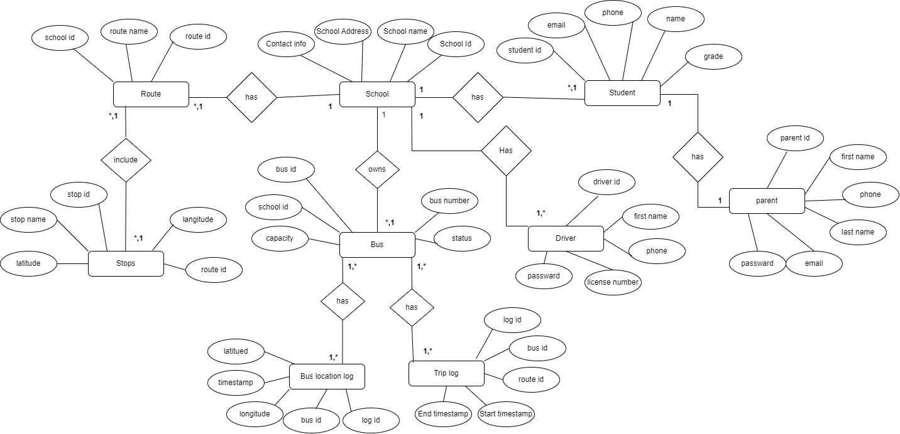

## USE CASE DIAGRAM

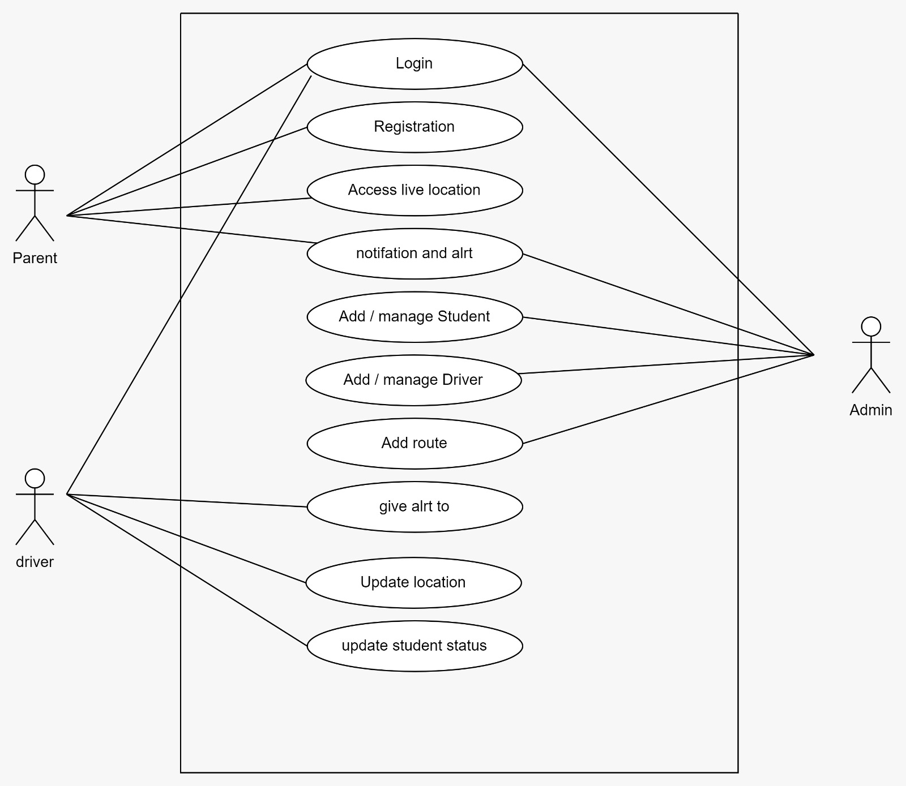

* 1. **CLASS DIAGRAM**

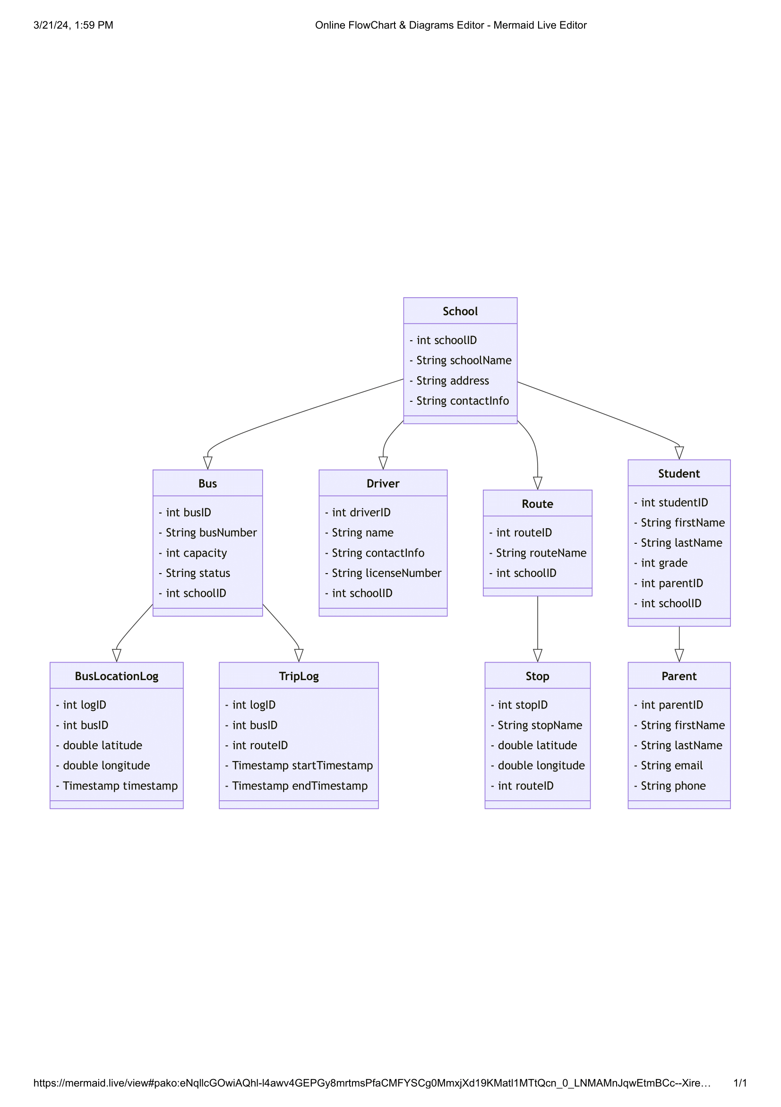

## ACTIVITY DIAGRAM

## Parent Activity

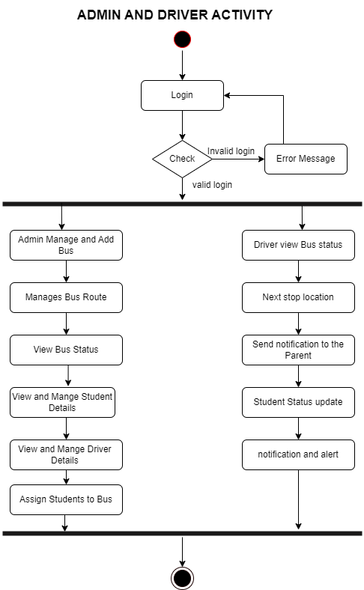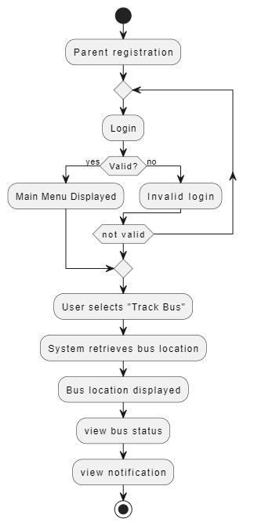

* 1. **SEQUENCE DIAGRAM**

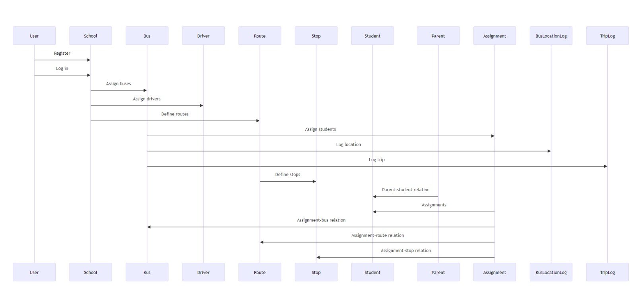

## DEPLOYMENT DIAGRAM

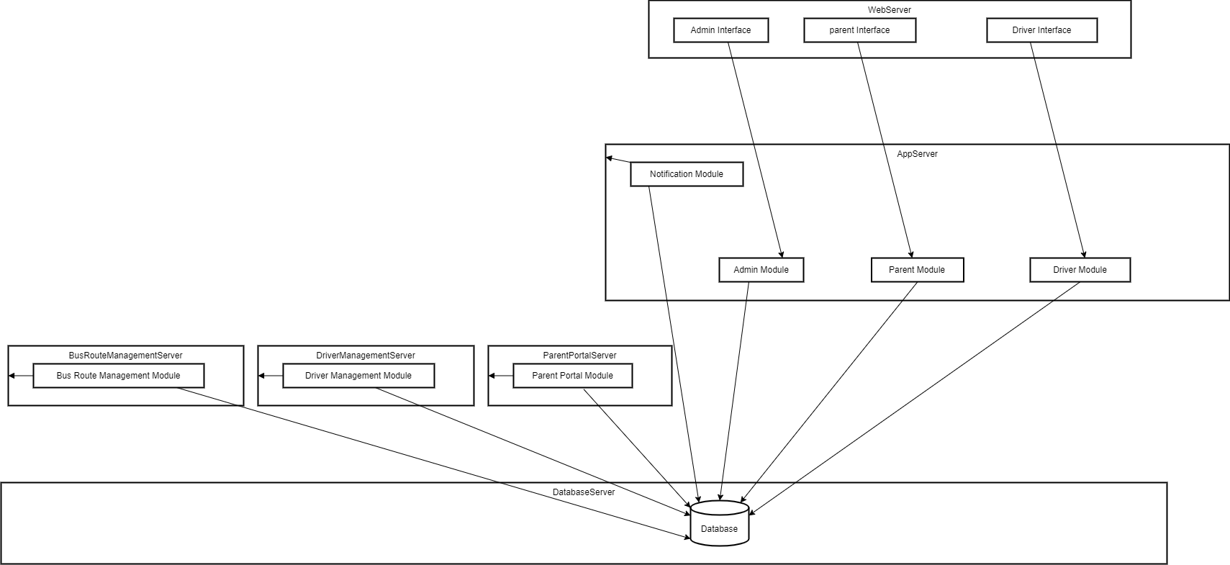

* 1. **MODULE HIERARCHY DIAGRAM**

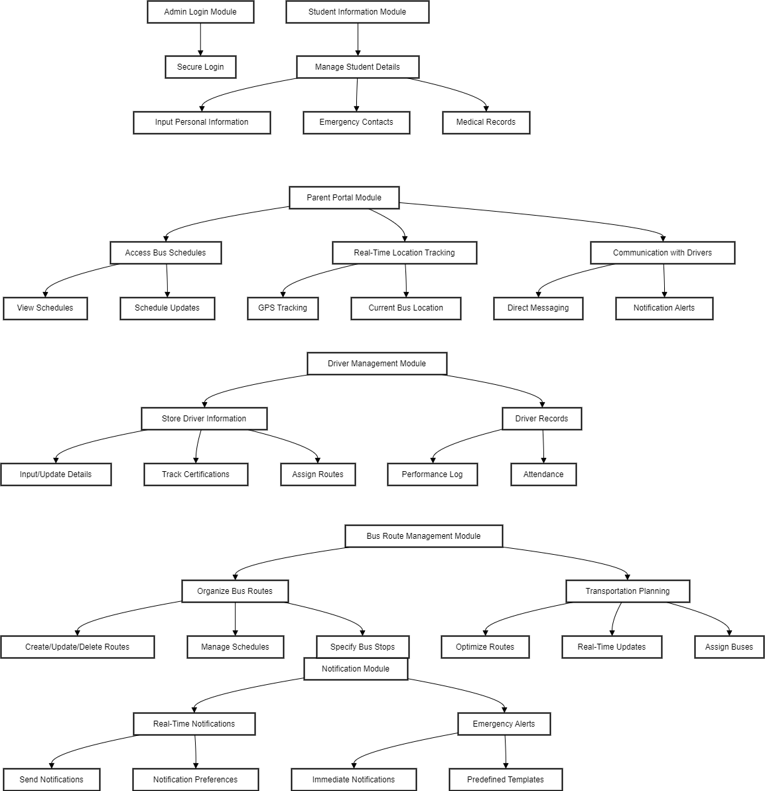

**3.9 TABLE STRUCTURE**

**Routes Table:**

|  |  |  |  |  |  |
| --- | --- | --- | --- | --- | --- |
| **Sr.No.** | **Column Name** | **Data type** | **Size** | **Constraints** | **Description** |
| **1.** | **RouteID** | **INT** | **20** | **Primary key** | **Route Id** |
| **2.** | **RouteName** | **VARCHAR** | **200** | **Not Null** | **Route Name** |
| **3.** | **SchoolID** | **INT** | **20** | **Foreign key** | **School Id** |

**Buses Table:-**

|  |  |  |  |  |  |
| --- | --- | --- | --- | --- | --- |
| **Sr.No.** | **Column Name** | **Data type** | **Size** | **Constraints** | **Description** |
| **1.** | **BusID** | **INT** | **20** | **Primary key** | **Bus Id** |
| **2.** | **BusNumber** | **VARCHAR** | **200** | **Not Null** | **Bus Number** |
| **3.** | **Capacity** | **INT** | **50** | **Not Null** | **Bus Capacity** |
| **4.** | **Status** | **VARCHAR** | **200** | **Not Null** | **Bus Status** |
| **5.** | **SchoolID** | **INT** | **20** | **Foreign key** | **School Id** |

**Stops Table:-**

|  |  |  |  |  |  |
| --- | --- | --- | --- | --- | --- |
| **Sr.No.** | **Column Name** | **Data type** | **Size** | **Constraints** | **Description** |
| **1.** | **StopID** | **INT** | **20** | **Primary key** | **Stop ID** |
| **2.** | **StopName** | **VARCHAR** | **200** | **Not Null** | **Stop name** |
| **3.** | **Latitude** | **FLOAT** | **50** | **Not Null** | **Bus Coordinates** |
| **4.** | **Longitude** | **FLOAT** | **50** | **Not Null** | **Bus Coordinates** |
| **5.** | **RouteID** | **INT** | **20** | **Foreign key** | **Route ID** |

**Parents Table:-**

|  |  |  |  |  |  |
| --- | --- | --- | --- | --- | --- |
| **Sr.No.** | **Column Name** | **Data type** | **Size** | **Constraints** | **Description** |
| **1.** | **ParentID** | **INT** | **20** | **Primary key** | **Parent Id** |
| **2.** | **FirstName** | **VARCHAR** | **50** | **Not Null** | **First Name** |
| **3.** | **LastName** | **VARCHAR** | **50** | **Not Null** | **Last Name** |
| **4.** | **Email** | **VARCHAR** | **50** | **Not Null** | **Email ID** |
| **5.** | **Phone** | **VARCHAR** | **50** | **Not Null** | **Phone No.** |

**Bus Location Table:-**

|  |  |  |  |  |  |
| --- | --- | --- | --- | --- | --- |
| **Sr.No.** | **Column Name** | **Data type** | **Size** | **Constraints** | **Description** |
| **1.** | **LogId** | **INT** | **20** | **Primary key** | **Log Id** |
| **2.** | **BusID** | **INT** | **20** | **Foreign key** | **Bus Id** |
| **3.** | **Latitude** | **FLOAT** | **50** | **Not Null** | **Bus Coordinates** |
| **4.** | **Longitude** | **FLOAT** | **50** | **Not Null** | **Bus Coordinates** |
| **5.** | **Timestamp** | **DATETIME** | **50** | **Not Null** | **Time Stamp** |

**Trip Log Table:-**

|  |  |  |  |  |  |
| --- | --- | --- | --- | --- | --- |
| **Sr.No.** | **Column Name** | **Data type** | **Size** | **Constraints** | **Description** |
| **1.** | LogId | INT | 20 | Primary key | Log Id |
| **2.** | BusId | INT | 20 | Foreign key | Bus Id |
| **3.** | RouteID | INT | 20 | Foreign key | Route Id |
| **4.** | StartTimeStamp | DATETIME | 50 | Not Null | Stating Time of Bus Trip |
| **5.** | EndTimeStamp | DATETIME | 50 | Not Null | Stating Time of Bus Trip |

**Students Table:**

|  |  |  |  |  |  |
| --- | --- | --- | --- | --- | --- |
| **Sr.No.** | **Column Name** | **Data type** | **Size** | **Constraints** | **Description** |
| **1.** | **StudentID** | **INT** | **20** | **Primary key** | **Student Id** |
| **2.** | **FirstName** | **VARCHAR** | **50** | **Not Null** | **Student First Name** |
| **3.** | **LastName** | **VARCHAR** | **50** | **Not Null** | **Student Last Name** |
| **4.** | **Grade** | **INT** | **20** | **Not Null** | **Student Grade** |
| **5.** | **ParentID** | **INT** | **50** | **Foreign key** | **Parent Id** |
| **6.** | **SchoolID** | **INT** | **20** | **Foreign key** | **School Id** |

## 3.10 SAMPLE INPUT AND OUTPUT SCREENS

**Admin Screens:-**

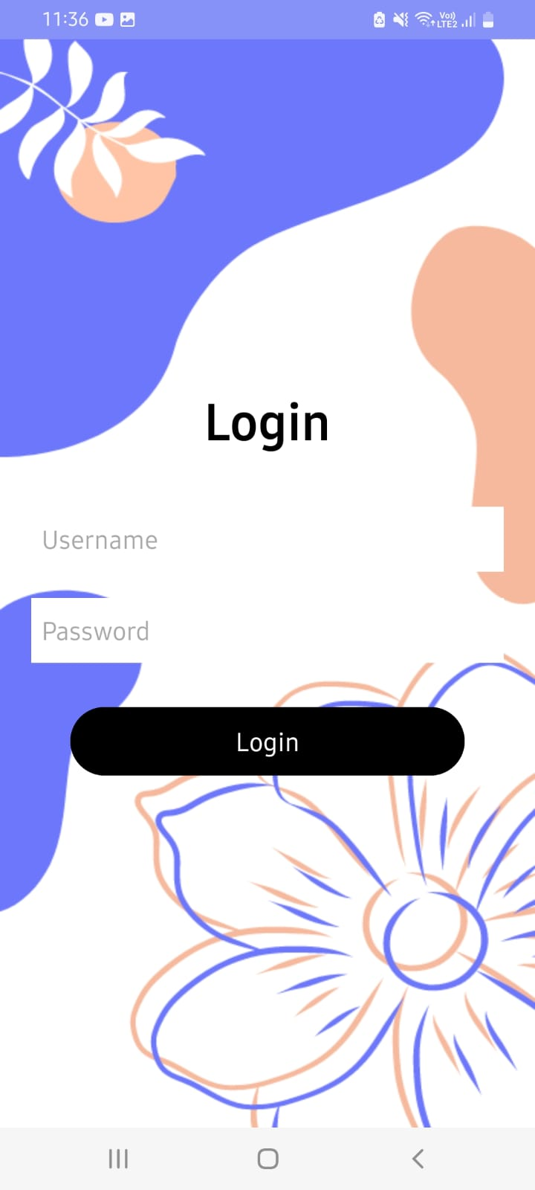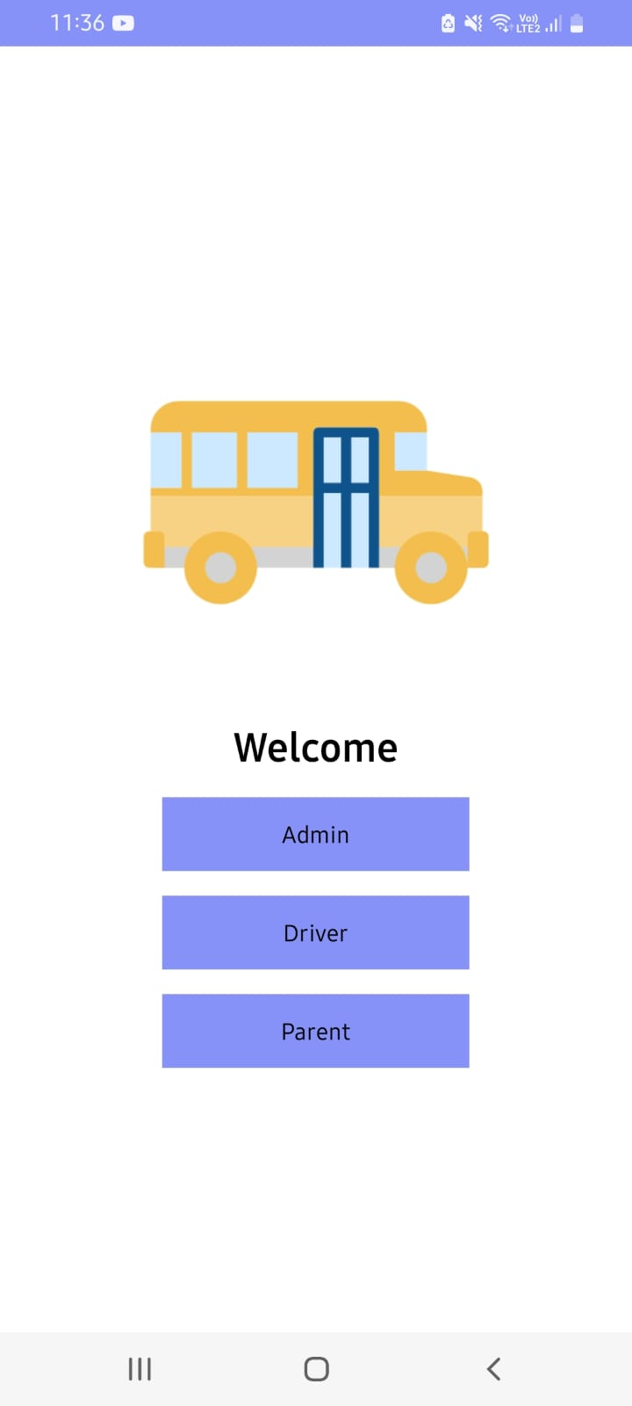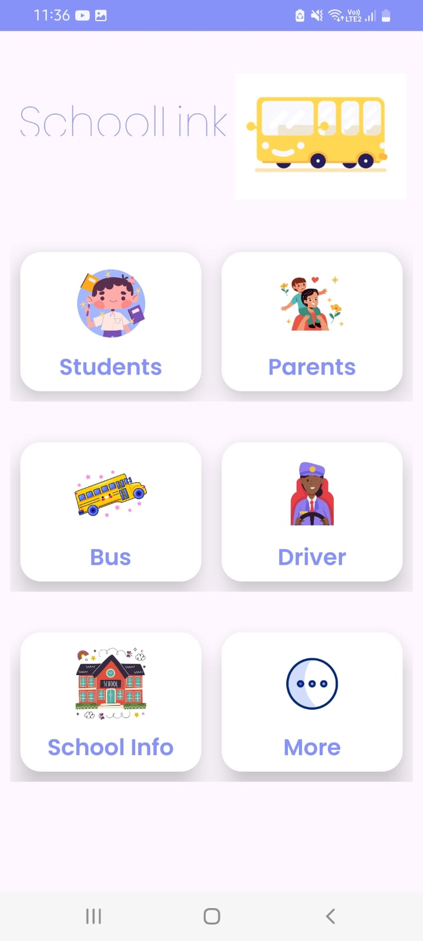

Student Details:-

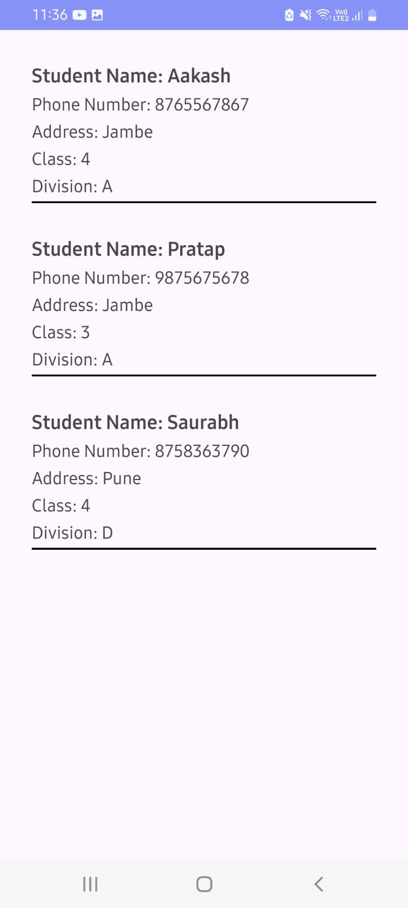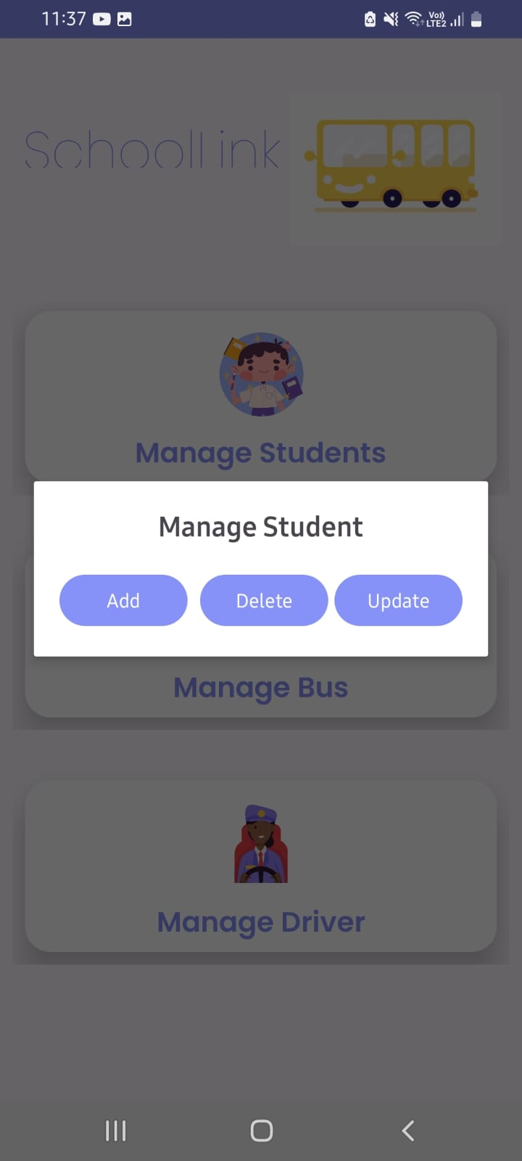

Parent Detail:- Driver Details:-

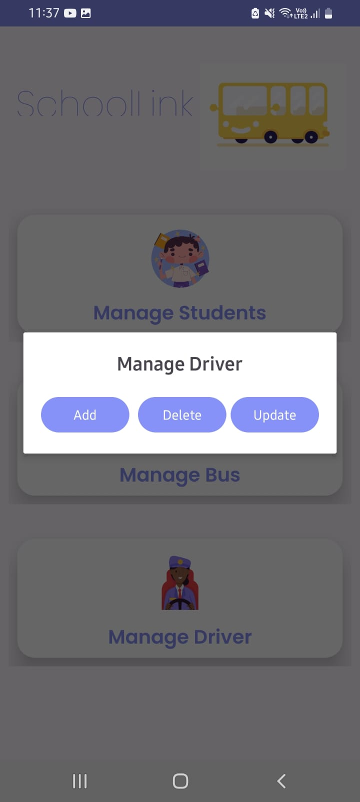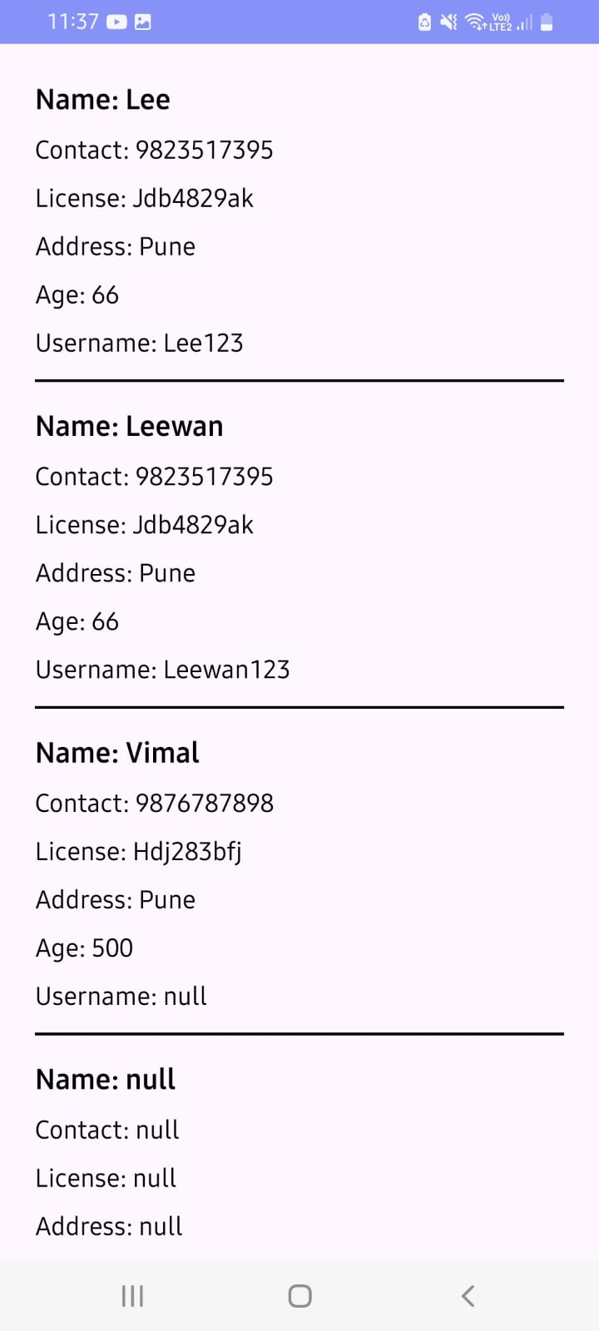

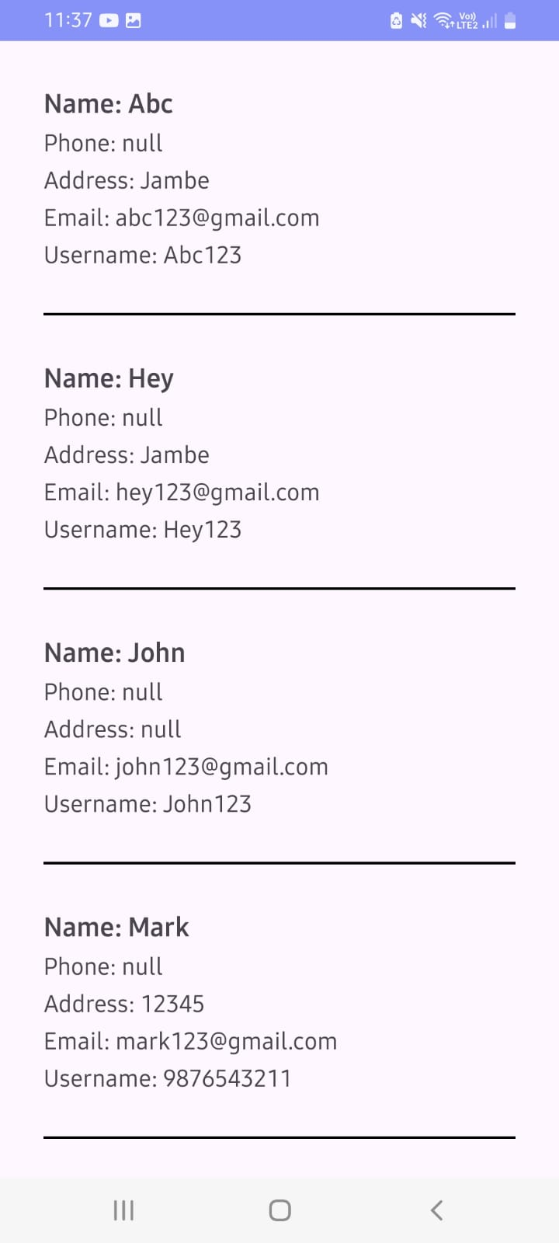

Bus Details:-

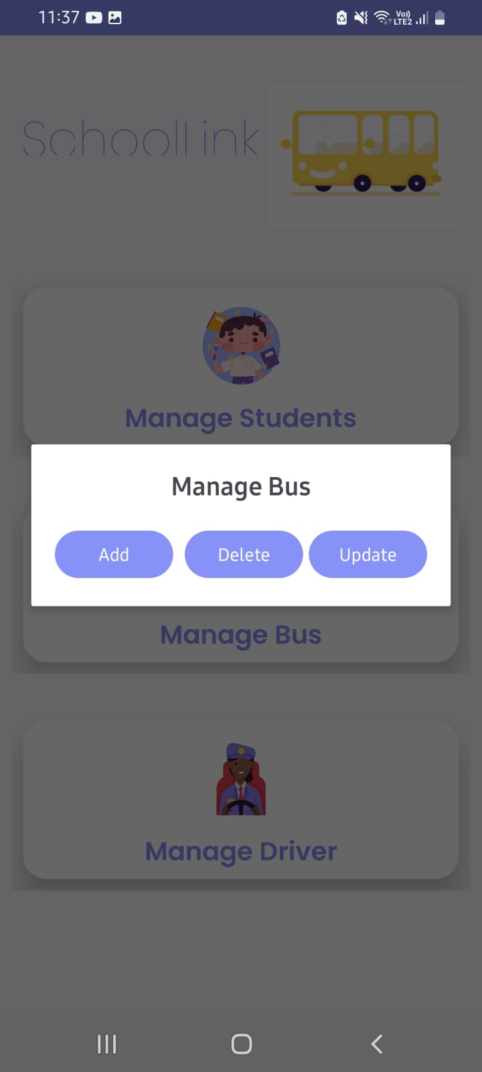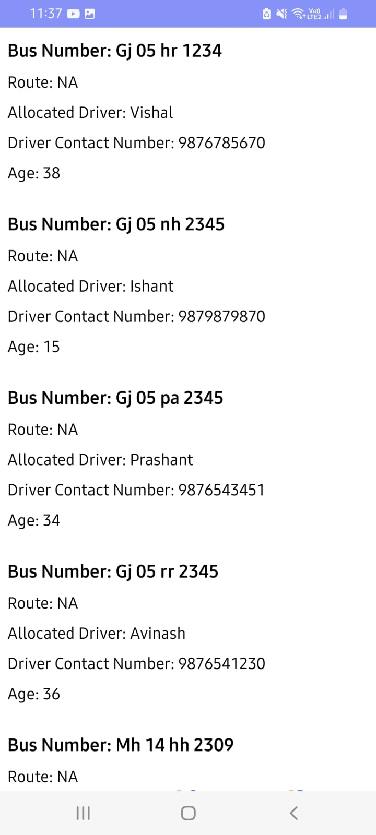

**Chapter No. 4**

**CODING**

## 4.1 CODING SNIPPETS

**activity_map.xml:-**

<?xml version="1.0" encoding="utf-8"?>

<RelativeLayout xmlns:android="http://schemas.android.com/apk/res/android"

xmlns:tools="http://schemas.android.com/tools"

android:layout_width="match_parent"

android:layout_height="match_parent"

tools:context=".driver.MapActivity">

<fragment

android:id="@+id/map"

android:name="com.google.android.gms.maps.SupportMapFragment"

android:layout_width="match_parent"

android:layout_height="match_parent" />

</RelativeLayout>

**MapActivity.java:-**

package com.example.schoollink_2.driver;

import android.Manifest;

import android.content.pm.PackageManager;

import android.os.Bundle;

import androidx.annotation.NonNull;

import androidx.core.app.ActivityCompat;

import androidx.core.content.ContextCompat;

import androidx.fragment.app.FragmentActivity;

import com.example.schoollink_2.R;

import com.google.android.gms.maps.CameraUpdateFactory;

import com.google.android.gms.maps.GoogleMap;

import com.google.android.gms.maps.OnMapReadyCallback;

import com.google.android.gms.maps.SupportMapFragment;

import com.google.android.gms.maps.model.LatLng;

import com.google.android.gms.maps.model.MarkerOptions;

public class MapActivity extends FragmentActivity implements OnMapReadyCallback {

private GoogleMap mMap;

private static final int LOCATION_PERMISSION_REQUEST_CODE = 1;

@Override

protected void onCreate(Bundle savedInstanceState) {

super.onCreate(savedInstanceState);

setContentView(R.layout.activity_map);

// Initialize map fragment

SupportMapFragment mapFragment = (SupportMapFragment) getSupportFragmentManager()

.findFragmentById(R.id.map);

if (mapFragment != null) {

mapFragment.getMapAsync(this);

}

// Check location permissions

if (ContextCompat.checkSelfPermission(this, Manifest.permission.ACCESS_FINE_LOCATION)

!= PackageManager.PERMISSION_GRANTED) {

ActivityCompat.requestPermissions(this,

new String[]{Manifest.permission.ACCESS_FINE_LOCATION},

LOCATION_PERMISSION_REQUEST_CODE);

}

}

@Override

public void onMapReady(GoogleMap googleMap) {

mMap = googleMap;

// Check if location permissions are granted

if (ContextCompat.checkSelfPermission(this, Manifest.permission.ACCESS_FINE_LOCATION)

== PackageManager.PERMISSION_GRANTED) {

mMap.setMyLocationEnabled(true);

getLastKnownLocation();

} else {

ActivityCompat.requestPermissions(this,

new String[]{Manifest.permission.ACCESS_FINE_LOCATION},

LOCATION_PERMISSION_REQUEST_CODE);

}

}

private void getLastKnownLocation() {

// If permissions are granted, enable my location on the map

if (ContextCompat.checkSelfPermission(this, Manifest.permission.ACCESS_FINE_LOCATION)

== PackageManager.PERMISSION_GRANTED) {

mMap.setMyLocationEnabled(true);

}

}

@Override

public void onRequestPermissionsResult(int requestCode, @NonNull String[] permissions,

@NonNull int[] grantResults) {

super.onRequestPermissionsResult(requestCode, permissions, grantResults);

if (requestCode == LOCATION_PERMISSION_REQUEST_CODE) {

if (grantResults.length > 0 && grantResults[0] == PackageManager.PERMISSION_GRANTED) {

// Permission granted, set my location enabled

if (ContextCompat.checkSelfPermission(this, Manifest.permission.ACCESS_FINE_LOCATION)

== PackageManager.PERMISSION_GRANTED) {

mMap.setMyLocationEnabled(true);

getLastKnownLocation();

}

} else {

// Permission denied, show a message to the user

// You can display a Toast or Snackbar to inform the user about the denied permission

}

}

}

}

**activity_trip_student.xml**

<?xml version="1.0" encoding="utf-8"?>

<androidx.drawerlayout.widget.DrawerLayout xmlns:android="http://schemas.android.com/apk/res/android"

xmlns:tools="http://schemas.android.com/tools"

xmlns:app="http://schemas.android.com/apk/res-auto"

android:id="@+id/drawer_layout"

android:layout_width="match_parent"

android:layout_height="match_parent"

tools:context=".driver.TripStudent">

<RelativeLayout

android:layout_width="match_parent"

android:layout_height="match_parent">

<androidx.appcompat.widget.Toolbar

android:id="@+id/toolbar"

android:layout_width="match_parent"

android:layout_height="wrap_content"

android:background="?attr/colorPrimary"

android:theme="@style/ThemeOverlay.AppCompat.ActionBar"

android:popupTheme="@style/ThemeOverlay.AppCompat.Light" />

<LinearLayout

android:id="@+id/studentListContainer1"

android:layout_width="match_parent"

android:layout_height="wrap_content"

android:layout_below="@id/toolbar"

android:orientation="vertical"

android:padding="8dp"

android:layout_marginRight="2dp"

android:layout_marginLeft="2dp">

<RelativeLayout

android:layout_width="match_parent"

android:layout_height="wrap_content">

<LinearLayout

android:id="@+id/studentListContainer"

android:layout_width="match_parent"

android:layout_height="wrap_content"

android:orientation="vertical"

android:layout_marginStart="10dp">

</LinearLayout>

</RelativeLayout>

</LinearLayout>

</RelativeLayout>

<com.google.android.material.navigation.NavigationView

android:id="@+id/nav_view"

android:layout_width="wrap_content"

android:layout_height="match_parent"

android:layout_gravity="start"

app:headerLayout="@layout/nav_header"

app:menu="@menu/drawer_menu" />

</androidx.drawerlayout.widget.DrawerLayout>

**Chapter No. 5**

**TESTING**

## TEST STRATEGY

**Unit Testing:**

Unit testing involves the examination of individual units or components of a software application in isolation from the rest of the system. Its purpose is to ensure that each unit functions correctly according to its specifications.

Typically conducted by developers during the coding phase, unit tests validate the behavior of small units of code, such as functions or methods, and detect any defects early in the development process.

## Integration Testing:

Integration testing focuses on testing the interactions between different units or components of the software. It ensures that these units work together seamlessly and that data flows correctly between them.

Integration testing is carried out after unit testing and before system testing, aiming to identify any issues that may arise due to the integration of various components.

## System Testing:

System testing evaluates the behavior of the complete and fully integrated software product as a whole. It verifies that the entire system meets specified requirements and functions correctly in its intended environment.

System testing encompasses various aspects such as functionality, usability, performance, security, and reliability, testing the system from end to end to ensure its readiness for deployment.

* Whether all the forms are properly working or not
* Whether all the forms are properly linked or not
* Whether all the images properly displayed or not.
* Whether data retrieval is proper or not.

## Test Cases

Test cases are built around specifications and requirements, i.e., what the application is supposed to do. Test cases are generally derived from external descriptions of the software, including specifications, requirements and design parameters.

Although the tests used are primarily functional in nature, non-functional tests may also be used. The test designer selects both valid and invalid inputs and determines the correct output without any knowledge of the test object's internal structure.

## Test Design Techniques

Typical black-box test design techniques include:

* Decision table testing
* All-pairs testing
* State transition Analysis
* Equivalence partitioning
* Boundary value analysis
* Cause-effect graph
* Error guessing

## TEST CASES

User Registration and Authentication:-

|  |  |  |  |  |
| --- | --- | --- | --- | --- |
| **Test Case ID** | **Description** | **Steps** | **Expected Result** | **Pass/Fail** |
| UA-001 | Register with Valid Credentials | Enter valid username, email, password, and confirm password. 2. Click on "Register" button. | User is successfully registered and redirected to the login page | Pass |
| UA-002 | Register with Existing Username | Enter existing username, click "Register | Error: Username already exists | Pass |
| UA-003 | |Register with Invalid Email | Enter invalid email, click "Register" | Error: Invalid email format | Pass |
| UA-004 | Login with Valid Credentials | Enter valid info, click "Login" | Successfully logged in and redirected to dashboard | Pass |
| UA-005 | Login with Invalid Username | Enter invalid username, click "Login" | Error: Invalid username | Pass |
| UA-006 | Login with Invalid Password | Enter invalid password, click "Login" | Error: Invalid password | Pass |
| UA-007 | Login with Blank Fields | Leave fields blank, click "Login" | Error: Required fields are empty | Pass |

**Bus Route Management:-**

|  |  |  |  |  |
| --- | --- | --- | --- | --- |
| **Test Case ID** | **Description** | **Steps** | **Expected Result** | **Pass/Fail** |
| BRM 001 | Add New Bus Route | Navigate to the bus route management section. Click on "Add Route". Enter route details. Click on "Save" button. | New bus route is successfully added to the system. | Pass |
| BRM 002 | Edit Existing Bus Route | Navigate to the bus route management section. Select the route to be edited. Make necessary changes. Click on "Save". | Changes to the bus route are successfully saved. | Pass |
| BRM 003 | Delete Bus Route | Navigate to the bus route management section. Select the route to be deleted. Click on "Delete" button. | Confirmation message appears. Upon confirmation, the route is deleted from the system | Pass |
| BRM 004 | View Bus Route Details | Navigate to the bus route management section. Select a bus route. | Detailed information about the selected bus route is displayed, including stops, timings, and other relevant details. | Pass |
| BRM 005 | Search for Bus Route | Navigate to the bus route management section. Enter search criteria in the search bar. Click on "Search" button. | Matching bus routes based on the search criteria are displayed. | Pass |

**Real-Time Bus Tracking:-**

|  |  |  |  |  |
| --- | --- | --- | --- | --- |
| **Test Case ID** | **Description** | **Steps** | **Expected Result** | **Pass/Fail** |
| RTBT-001 | Track Bus Location | Open Real-Time Bus Tracking. View map. | Map shows accurate real-time bus location. | Pass |
| RTBT-002 | Zoom In/Out on Map | Open Real-Time Bus Tracking. Use zoom. | Map zooms without distortion. | Pass |
| RTBT-003 | View Bus Route on Map | Open Real-Time Bus Tracking. Select route. | Map shows selected route and bus location. | Pass |
| RTBT-004 | Display Bus Information | Open Real-Time Bus Tracking. Click bus. | Popup shows bus details (route, driver, status). | Pass |
| RTBT-005 | Navigate to Bus Stop | Open Real-Time Bus Tracking. Click stop. | Map focuses on selected stop. | Pass |

**Bus Management:-**

|  |  |  |  |  |
| --- | --- | --- | --- | --- |
| **Test Id** | **Description** | **Steps** | **Expected Result** | **Pass/Fail** |
| BM-001 | Add New Bus | Access bus management, add details, save | New bus added successfully. | pass |
| BM-002 | Edit Bus Details | Access bus, modify details, save. | Changes to bus details saved. | pass |
| BM-003 | Delete Bus | Access bus, delete, confirm. | Bus removed from system. | pass |
| BM-004 | View Bus Details | Access bus, view details. | Detailed bus info displayed. | pass |

**Automated Notifications:-**

|  |  |  |  |  |
| --- | --- | --- | --- | --- |
| **TEST ID** | **Description** | **Steps** | **Expected Result** | **Pass /fail** |
| AN-001 | Receive Arrival Notification | Wait for scheduled arrival. Check device. | Parent receives arrival notification. | Pass |
| AN-002 | Receive Departure Notification | Wait for scheduled departure. Check device. | Parent receives departure notification. | Pass |
| AN-003 | Receive Delay Notification | Introduce delay, check for notification | Parent receives delay notification. | Pass |
| AN-004 | Receive Route Change Notification | Change route, wait for notification. | Parent don’t receives route change notification. | Fail |
| AN-005 | Receive Emergency Notification | Simulate emergency, check for notification. | Parent receives emergency notification. | Pass |

**Chapter No. 6**

**LIMITATIONS OF PROPOSED SYSTEMS**

**LIMITATIONS OF THE PROPOSED SYSTEM**

Limitations of the Proposed System:

## Digital Divide:

## The proposed system may inadvertently exacerbate the digital divide by assuming universal internet access and tech literacy.Students must recognize that not all users have equal access to technology or possess the same level of comfort with online platforms.Failure to address this divide could lead to exclusion and disenfranchisement among certain user demographics.

## Technical Issues:

## Implementing the proposed system may pose technical challenges, especially for users with limited technical expertise. Students should acknowledge that complex systems require robust technical support and resources for troubleshooting. Failure to provide adequate support could result in frustration and disengagement among users.

## Data Security Concerns:

## Storing sensitive user data within the proposed system introduces potential security vulnerabilities. Students should understand that any data breach or cyber-attack could compromise user privacy and erode trust in the system. Implementing robust security measures and adhering to data protection protocols are essential to mitigate these risks.

## Regulatory Compliance:

## As user demand grows, scalability becomes a critical consideration for the proposed system. Students must recognize that system architecture and infrastructure must be able to accommodate increasing user loads without compromising performance.

## Failure to plan for scalability could lead to system downtime and user dissatisfaction.

**Chapter No. 7**

**PROPOSED ENHANCEMENT**

## PROPOSED ENHANCEMENT

Current system is developed according to current requirements which can be added later. In this, the system can be merged with another system to make a bigger system invoking many functions on it, fostering interoperability and expansion possibilities for future integration with complementary systems.

No project is ever complete in itself; there are always minor or major changes in the project according to user requirements, emphasizing the iterative nature of software development and the importance of ongoing adaptation to meet evolving needs.

This project could be enhanced in the sense that it can overcome its limitations in the future, serving as a springboard for continuous improvement and innovation to address emerging challenges and seize new opportunities.

Latest electronic and software technologies can help to bring in more enhancements which would help to make the system more user-friendly and also help to maintain adequate security, leveraging advancements in technology to enhance usability, performance, and security posture, ensuring that the system remains robust and resilient against potential threats.

To make the application as online so that it would be helpful to everyone, extending accessibility and convenience by transitioning the application to an online platform, enabling broader reach and facilitating seamless access for users across different locations and devices.

**Chapter No. 8**

**CONCLUSION**

## CONCLUSION

We have endeavored to develop "The School-link" application to significantly aid the modern educational landscape by registering user requirements and ensuring seamless integration into existing workflows. Our design philosophy emphasizes flexibility, leaving all options open to accommodate future enhancements as dictated

by user needs. This approach ensures adaptability and scalability, making the system capable of evolving with changing demands.

"The School-link" is designed to provide a comprehensive organizer with a robust operating and management system. It includes features for adding and managing students, teachers, courses, and schedules, ensuring that all necessary functionalities

are available to meet diverse educational requirements. The system's user-friendly and flexible interface is designed to streamline interactions, accommodate users of varying expertise, and foster efficiency and ease of use.

We are confident that this project will fulfill its intended purpose, marking a significant milestone in addressing the organizational and operational needs of modern educational institutions. By achieving the project's objectives, we aim to underline its success and utility in enhancing school processes and management.

**Chapter No. 9**

**BIBLIOGRAPHY**

## BIBLIOGRAPHY

* **Website Reference**
  + [https://www.w3schools.com](https://www.w3schools.com/)

•

[https://androidknowledge.com/ https://androidknowledge.com/.com/](https://androidknowledge.com/%20https://androidknowledge.com/.com/)

•

https://firebase.google.com/

* + <https://www.wikipedia.org/>
  + [www.geeksforgeeks.org](http://www.geeksforgeeks.org/)

## Books Reference

* + “Rich development environment”
  + "Java Programming for android Developers"

**Chapter No. 10**

**USER MANUAL**

## USER MANUAL : ADMIN SIDE

## 

**Admin Screens:-**









